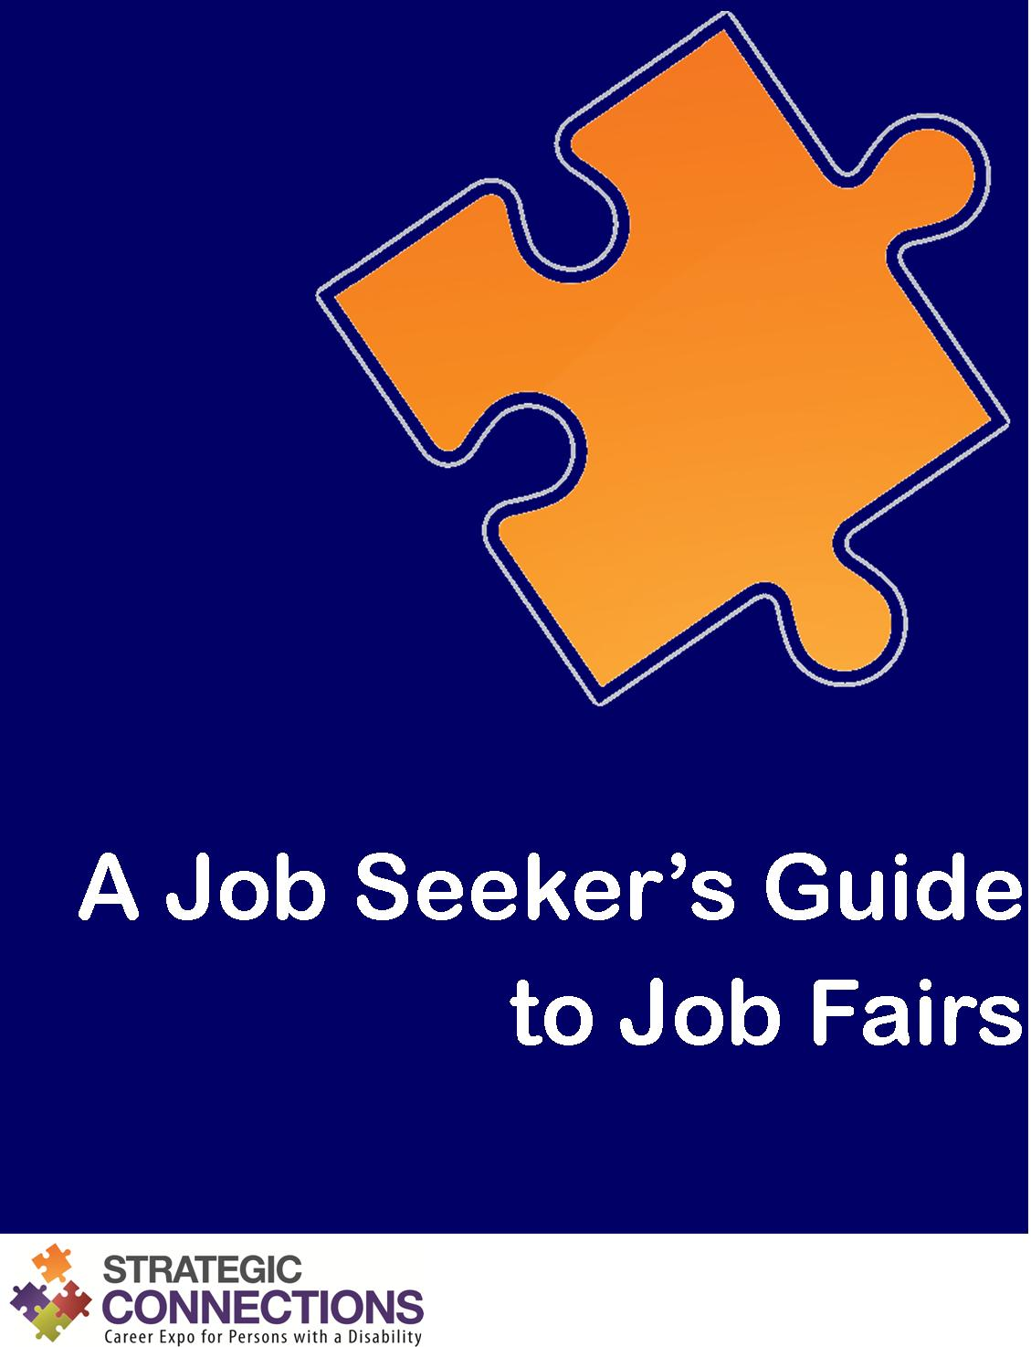

A Job Seeker’s Guide to Job Fairs
Ready and Able to Work!

What is a job fair?
A job fair is typically a one day event that brings together job seekers with many employers at one time. It is a convenient way for job seekers with a disability to apply for numerous job openings and get immediate interviews.
Employers participate in job fairs to meet and attract qualified individuals to their companies or organizations. Most are looking to fill existing job openings or ones that will be available in the near future.
At a job fair, each employer sets up a booth. Job seekers with a disability visit the various booths to learn about the employers, identify potential employment opportunities, and apply for open positions. Employer representatives are there to provide information, answer questions, collect resumes, screen candidates, and even conduct on-the-spot interviews.

What’s in it for me?
- Meet numerous employers face to face
- Identify potential job opportunities
- Learn more about employers that interest you
- Build a valuable network of contacts

How do I make the most of the job fair?
Be ready and able to work, of course!

Ready
Get ready to outshine all of the others. Preparation is key before the job fair.
- Do your research
- Develop your plan
- Prepare questions to ask
- Get your resume ready
- Write and rehearse your self-introduction
- Practice for employment interviews
- Conduct an online reputation check

Able
Present your best self at the job fair. Show employers what you are able to do.
- Dress for success
- Be an observer
- Approach employers
- Take notes
- Be ready for on-the-spot opportunities
- Network with others
- Stay fresh
- Get contact information for follow up

Work
You are not done yet! There is still work to be done after the job fair.
- Reflect on the experience
- Follow up promptly
- Keep a log

Ready

Do your research
Find out what employers will be attending the job fair. Research the companies and organizations that interest you. Employers’ websites are a good place to start. Know the industry you are targeting and use the appropriate buzz words and phrasing.

Develop your plan
Job fairs can be very busy events. Block out enough time from your schedule to attend. Prioritize the employers you want to meet. Make preparations to arrive early. Employers tend to remember the people they meet first. Others tend to become a blur later on in the day. Arriving early will also give you an opportunity to scope out the venue and plan your strategy for meeting your targeted employers.

Prepare questions to ask
Prepare a list of questions to ask. Ask open-ended questions to initiate meaningful conversation. Do not ask about information that is readily available on the employer’s website. Do not directly ask for a job. Do not ask about salary or benefits. These topics should be initiated by the employer.

Get your resume ready
Tailor your resume to your specific career goals. You may wish to have several versions. Create a separate reference page with the same look and feel as your resume. Print sufficient copies of your resume and reference page to bring with you on the day of the job fair. Documents should be crisp and clean, so place them in a professional zip up portfolio or twin pocket folder. Be aware that not all employers will accept paper copies of your resume. You may be required to apply online or via email. For this reason, have your resume, cover letters, and reference page saved on your computer or a USB stick.

Write and rehearse your self-introduction
Write a short self-introduction that you can recite when you meet employers. Your self-introduction should explain your education, experience, skills, goals, and why you are interested in a particular company or organization. Before attending the job fair, practice delivering your self-introduction to someone you know or in the mirror. It should come across as natural and professional. Your delivery is just as important as the content!

Practice for employment interviews
Be prepared to answer commonly asked interview questions. Prepare your responses ahead of time and practice, practice, practice!

Conduct an online reputation check
Many employers are now checking social media to find out more about you. Before attending the job fair, do an online reputation check. Google yourself to see what comes up. Comb through your social media accounts and remove anything you would not want a future employer to see. Adjust the privacy settings on your accounts. Review your email address to make sure it is appropriate for job searching. Email addresses like “hottiechick@hotmail.com” give a negative impression to potential employers.

Able

Dress for success
First impressions are important! Dress professionally as you would for a job interview. No jeans, sneakers, low cut tops, short skirts, or bare midriffs. Make sure your clothes are clean and wrinkle free. Wear comfortable shoes. You may be walking or standing in line for long periods of time. Be well groomed. Be conscious of your odor. Wear deodorant. Do not smoke, and do not wear strong perfume or cologne.

Be an observer
When you first arrive at the job fair, do a walk-through of the entire event. Locate your target employers and plan your strategy. Take note of employers who are conducting on-the-spot interviews. These people are serious about hiring! Whenever possible try to identify the highest level employer representative or the person conducting interviews. These are the people you want to meet.

Approach employers
Approach employers alone, not in pairs or groups. Smile, make eye contact, and give a firm handshake. Show interest and enthusiasm. Deliver your short self-introduction and ask your prepared questions. Listen carefully to employers to understand their needs and priorities. Make sure your cell phone is turned off so that you are not distracted.

Take notes
Bring paper and a pen. Keep a list of the employers you meet. Make notes of your conversations with employers to look back on when it is time to follow up.

Be ready for on-the-spot opportunities
Be ready for on-the-spot interviews. If you are given an application or asked to apply online, take time to fill it out immediately if possible. Make sure it is done carefully and completely. From an employer’s perspective, the way you fill out an application is a reflection of your work. Submit it right away unless otherwise directed. If you take it home, you might lose out to better prepared candidates.

Network with others
Strike up conversations with other job fair attendees while you are waiting in line or taking a short break. You will be surrounded by others with all kinds of backgrounds. Some of them might have valuable information or contacts that could lead you to a job.

Stay fresh
Take necessary breaks and stay hydrated. But remember, employers are always watching. Be professional at all times. Do not approach any employer booths with food, drink, or gum in your mouth.

Get contact information for follow up
At the end of the meeting, ask employers about next steps. Thank employers for their time, and request a business card for follow up. If an employer does not have one, take note of the contact information.

Work

Reflect on the experience
First, applaud yourself for a job well done. Reflect on what went well and what you could do to improve next time. Review your notes and devise a plan for following up.

Follow up promptly
Follow up within two days of the job fair. Send personalized thank you notes along with your resume to reiterate your interest and remind them of you. Email is fine, but an actual card or letter may leave a more lasting impression. If you have not heard from an employer after two weeks, you may wish to call to verify that your application has been received and to check the status of the position.

Keep a log
Keep a log of all employers you contact. Include information such as dates and times of calls and copies of all application materials sent.

