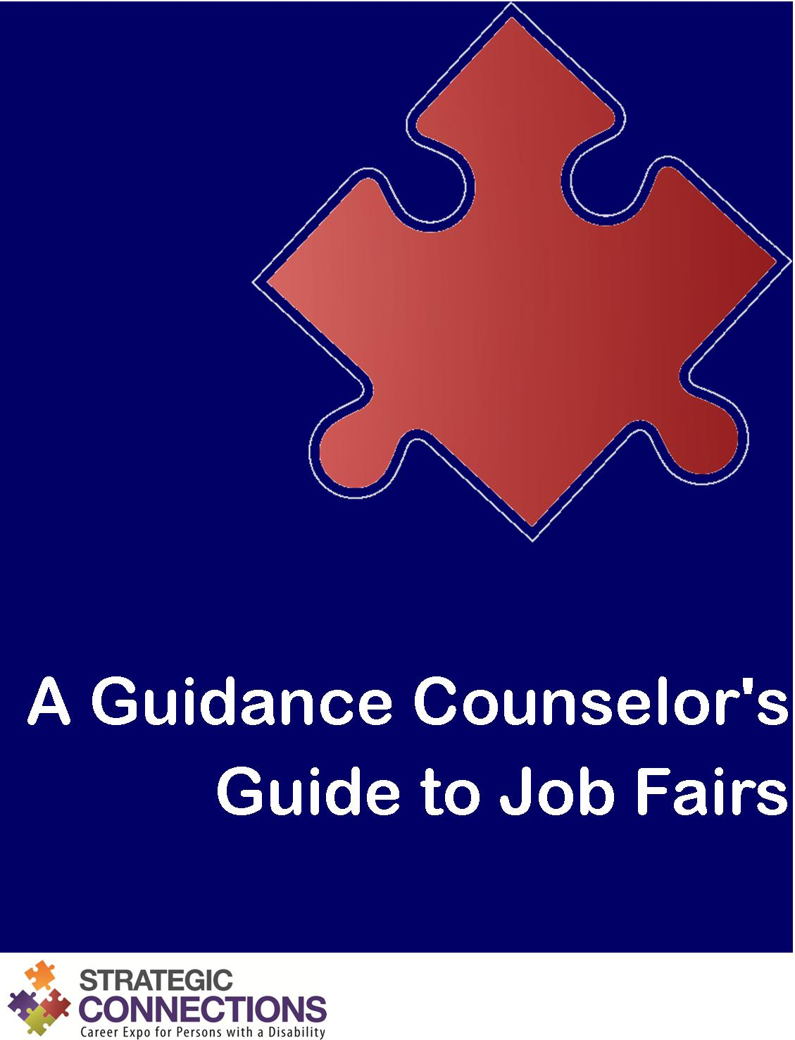

An Agency’s Guide to Job Fairs
Ready and Able to Assist!

What is a job fair?
A job fair is typically a one day event that allows job seekers to meet with many employers at one time. It is a convenient way for job seekers with a disability to apply for numerous job openings and get immediate interviews.
Employers participate in job fairs to meet and attract qualified individuals to their companies or organizations. Most are looking to fill existing job openings or ones that will be available in the near future.
At a job fair, each employer sets up a booth. Job seekers with a disability visit the various booths to learn about the employers, identify potential employment opportunities, and apply for open positions. Employer representatives are there to provide information, answer questions, collect resumes, screen candidates, and even conduct on-the-spot interviews.

What’s in it for students with a disability?
- Meet numerous employers face to face
- Identify potential job opportunities
- Learn more about employers of interest
- Build a valuable network of contacts

How do I assist students with a disability to make the most of the job fair?
Be ready and able to assist, of course!

Ready
Support students with a disability in getting ready for the job fair.
- Communicate with job fair organizers
- Distribute resources
- Hold workshops for students with a disability
- Teach students with a disability techniques for researching employers
- Provide access to computers and equipment
- Help students with a disability develop a plan

Able
Encourage students with a disability to see all they are able to do.
- Support students with a disability in career exploration and planning
- Assist with resumes, cover letters, and reference sheets

Assist
Assist students with a disability in showcasing what they have to offer.
- Discuss dress and deportment
- Prepare students with a disability for employment interviews
- Provide opportunities for practice

Ready

Communicate with job fair organizers
Get as much information as possible from job fair organizers. See what resources they have available. Get a list of employers who will be participating. Find out about the venue. Having this information and passing it along to students with a disability will ensure that they are as prepared as possible for the event.

Distribute resources
Job fair organizers often provide resources, such as job fair guides and maps of the venue. Make sure these are readily available to your students with a disability, either in print format or electronically. Direct students with a disability to the job fair’s website if available.

Hold workshops for students with a disability
Consider holding workshops to help students with a disability prepare for the job fair. These workshops could include topics like resume writing, interview preparation, and networking.

Teach students with a disability techniques for researching employers
Employers are impressed by individuals who have some background knowledge of their company or organization. They are looking for job seekers with a disability to show genuine interest. Teach students with a disability how to research employers. This could include visiting an employer’s website, contacting an employer for information, or gathering printed literature about an employer.

Provide access to computers and equipment
Make sure students with a disability have access to all the tools they need to prepare for the job fair and successfully secure employment. This includes computers, printers, photocopiers, fax machines, and USB sticks.

Help students with a disability develop a plan
Help students with a disability develop a plan for the day of the job fair. This could include such things as arranging transportation to and from the event or deciding what to wear. It should also include helping students with a disability prioritize the employers they want to meet and deciding on a plan of attack.

Able

Support students with a disability in career exploration and planning
For job seekers with a disability to get the full benefit of a job fair, they must have clear career goals and an action plan to get there. Self-assessment is often the first step. Job seekers with a disability should have a clear understanding of their values, beliefs, interests, abilities, and skills and be able to communicate this information to employers. This will go a long way in helping them secure employment that is the right fit. You play an integral role in guiding students with a disability through this process.

Assist with resumes, cover letters, and references
A strong resume is a real confidence booster for students with a disability and will help them see all that they have to offer. Assist students with a disability in writing and formatting resumes tailored to their specific career goals. Students with a disability may also want to write cover letters targeting positions with specific employers. All job seekers with a disability should have a separate page with at least three references. Help students with a disability identify appropriate references if needed. Have them use the same header on all of their documents to create a cohesive package.

Assist

Discuss dress and deportment
Creating a positive first impression is paramount for job seekers with a disability. As a guidance counselor, you play an important role in discussing sensitive topics such as hygiene, appropriate dress, and body language with students with a disability.

Prepare students with a disability for employment interviews
Help students with a disability write a script to introduce themselves to employers. This self–introduction should include the student’s education, experience, skills, and goals. Provide students with a disability with a list of commonly asked interview questions, so they can prepare responses ahead of time. Have them identify validating experiences to prove that they actually possess the skills they claim to have.

Provide opportunities for practice
Provide lots of opportunities for students with a disability to practice before the job fair. This could be rehearsing their self-introduction, participating in mock interviews, or even just practicing their handshakes and smiles. Whatever it is, be a safe place where students with a disability can get all the jitters out before the real deal.

