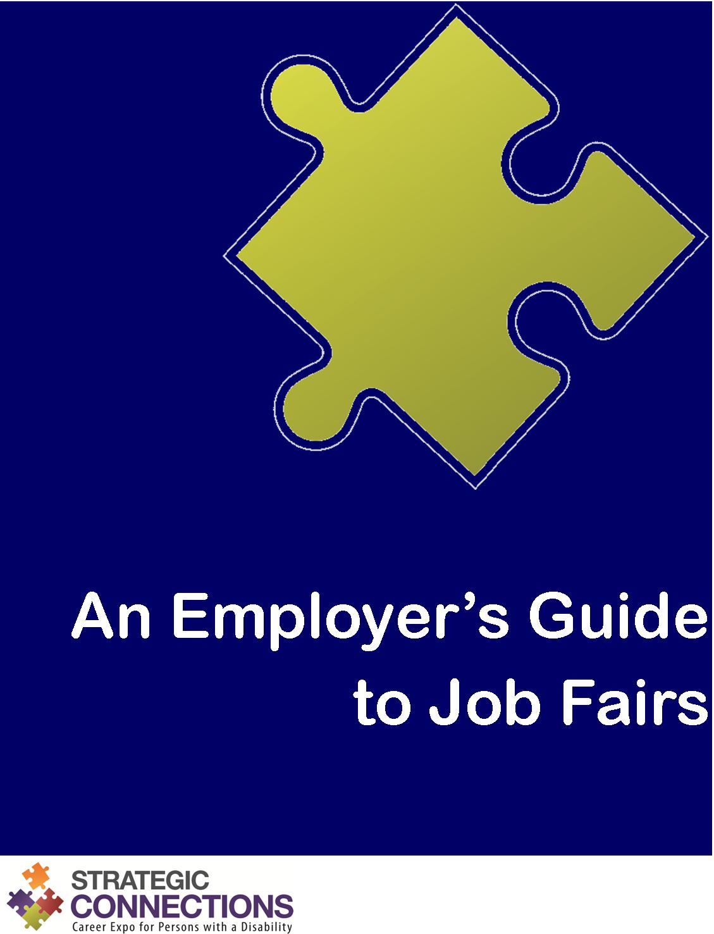

An Employer’s Guide to Job Fairs
Ready and Able to Hire!

What is a job fair?
A job fair is typically a one day event that allows job seekers to meet with many employers at one time. It is a convenient way for job seekers with a disability to apply for numerous job openings and get immediate interviews.
Employers participate in job fairs to meet and attract qualified individuals to their companies or organizations. Most are looking to fill existing job openings or ones that will be available in the near future.
At a job fair, each employer sets up a booth. Job seekers with a disability visit the various booths to learn about the employers, identify potential employment opportunities, and apply for open positions. Employer representatives are there to provide information, answer questions, collect resumes, screen candidates, and even conduct on-the-spot interviews.

What’s in it for me?
- Gain exposure for your company or organization
- Recruit highly talented individuals
- Network with other professionals

How do I make the most of the job fair?
Be ready and able to hire, of course!

Ready
Get ready for the job fair.
- Register
- Do your homework
- Choose your representatives
- Design your booth
- Select literature and brochures
- Do a practice run

Able
Be open to what job seekers with a disability are able to do for you.
- Be available and approachable
- Dress appropriately
- Make conversations productive
- Review applications as collected
- Have an organized system for follow-up
- Conduct on-the-spot interviews
- Network with others

Hire
Do what you were there to do. Hire!
- Follow up with applicants
- Assess your success
- Follow up with job fair organizers

Ready

Register
Register with job fair organizers to confirm your participation as soon as possible. Many venues are limited in the amount of space available, so registering early will ensure that you have a spot. Most job fair organizers provide a list of all employers participating. This allows job seekers with a disability to prepare ahead of time for the employers they want to meet. You want to be on that list. Registering with job fair organizers will ensure that you are. Many job fairs are organized by sector. When registering, you may wish to indicate which sector you would like to be identified with.

Do your homework
Find out who will be attending the job fair. Know your target audience and research the other employers and agencies attending. This will allow you to craft your message to fit the overall theme of the job fair and ensure that you stand out in the crowd. Get an understanding of the venue, so you know how much space you will have to work with.

Choose your representatives
Choose staff to attend the job fair. These representatives should be outgoing and knowledgeable. Job seekers with a disability will likely have lots of questions. Have at least two staff to interact with job seekers with a disability. This will help keep lines short and ensure that your booth is never left unattended. If possible, try to have a mix of HR and non-HR staff at the job fair to provide a well-rounded perspective to job seekers with a disability. You may also want to have a mix of male and female representatives.

Design your booth
First impressions are lasting impressions. Make your booth interesting and attractive. Think carefully about your message, brand, and objectives for the job fair. Using a banner, pictures, and signs can be effective, but keep lengthy text to a minimum. Keep your message short and simple. You may wish to include freebies or give-aways at your booth. Choose something creative that job seekers with a disability will remember or something useful that they will hold on to, but keep in mind that people tend to remember the feeling they get from the personalities they meet much more than the free stuff.

Select literature and brochures
Supply your booth with brochures or leaflets explaining your company or organization, descriptions of the various positions available, applications forms, and business cards.

Do a practice run
Although not essential, it might be a good idea to do a practice run before the job fair to prevent any issues that may arise. This could include making sure you know how to get to the venue, setting up your stand, determining how long it takes to set up and tear down, and practicing with a couple of mock job seekers.

Able

Be available and approachable
First impressions go both ways. Just as a job seeker with a disability leaves an impression on you, you leave a lasting impression of your company or organization with him or her. Make sure it is a positive one. Be open and available. Do not spend your time chatting with co-workers at your booth. Word will travel fast if job seekers with a disability feel they were dismissed or ignored. If possible, stand up and engage job seekers with a disability in conversation as they go by. Avoid sitting and talking across the table. Do not leave your booth unattended or leave the event before the end. An empty booth gives a negative impression.

Dress appropriately
It is understood that you should dress professionally to project a positive image of your company or organization. Something you may not have considered is dressing in layers. Temperatures in large venues with lots of people can be very unpredictable. Another tip is to make sure you wear comfortable shoes as you will likely spend most of your time standing.

Make conversations productive
Speak with as many job seekers with a disability as possible. Be careful not to let one person monopolize your time. Make sure your interaction goes both ways and is not just a one-way speech. Ask questions and give job seekers with a disability the opportunity to ask questions as well. Brochures and literature are a great resource but should not be used as a substitute for real conversation.

Review applications as collected
If you are collecting resumes or applications at your booth, review them as you go. Get job seekers with a disability to elaborate on their qualifications while you have them in front of you. If you are not collecting resumes or applications, make sure job seekers with a disability understand how to apply for available positions.

Have an organized system for follow-up
While reviewing resumes and applications, find a way to discreetly mark the ones that you are interested in. Put brief comments on resumes to remind you of your conversations. This will make following up after the job fair easier.

Conduct on-the-spot interviews
The goal of most job seekers with a disability is to be asked for an interview. Schedule interviews with the top applicants. If possible, conduct on-the-spot interviews at the job fair.

Network with others
Although your focus should be on the job seekers with a disability, it is advisable to take some time during slow periods to meet with other employers and professionals at the job fair. However, make sure there is always someone staffing your booth.

Hire

Follow up with applicants
Make sure all applicants and inquiries are responded to within ten days of the job fair. Strong applicants will likely get multiple offers, so follow up as quickly as possible to ensure your company or organization does not lose out. Be straightforward with applicants who did not make the cut. It might be disappointing, but honesty is the best policy.

Assess your success
After the job fair, evaluate your participation in the event. Consider the feedback you received from job seekers with a disability and other job fair attendees. Document the number of people who visited your booth, the number of applications received, the number of offers made, and the number of successful hires. Ask yourself what worked and what could be improved next time.

Follow up with job fair organizers
Job fair organizers will appreciate feedback about the event. They will be especially interested in hearing about successful hires.

